ECEN 5803 MASTERING EMBEDDED SYSTEMS ARCHITECTURE

Project 2

|  |  |  |
| --- | --- | --- |
| SR NO | INDEX  TITLE | PAGE NO |
| 1 | Executive Summary | 2 |
| 2 | Problem Statement | 2 |
| 3 | Objective | 2 |
| 4 | Block Diagram | 3 |
| 5 | Hardware Evaluation | 4 |
| 6 | Module Test Results | 5 |
| 7 | List of Project Deliverables | 6 |
| 8 | Recommendation | 6 |
| 9 | References | 7 |
| 10 | Project Staffing | 7 |

# Executive summary:

The report presents a brief overview of various tests carried out on Cortex m4 processor to determine its suitability for designing signal analyzer. The cortex m4 has number of peripherals like UART, SPI, I2C that makes it very useful to design signal analyzer. Moreover, the price of Cortex m4 is about 5 dollars that makes it perfectly suitable for keeping the budget within constraint. The Cortex m4 processor can support all the requirements which are laid down by Keithley, and one of the interesting feature is its support to multithreading operation which proves to be quite effective to handle many tasks in short period of time.. The cortex m4 processor was evaluated for performance by testing how effectively it can support four threads, and the results demonstrated that it was effective in supporting multithreading operations. Another advantage of using cortex m4 processor is its support to floating point and DSP operation which are very much likely to be used in signal analyzer.

Based on the requirements laid out by Keithley, various test have been performed which proves the feasibility of Cortex m4 to be used in Signal analyzer. The Cortex m4 processor architecture makes it easy to support the interrupts, PWM output, and multithreading which serves to be important for the operation of signal analyzer. Also, the system clock frequency of Cortex m4 is about 72 MHz which makes it possible to operate it at very high speed.

Though the implementation looks to be nearly perfect in its initial stage, there are few optimizations regarding hardware and software which are yet to be done to make the product follow the triple point constraint of budget vs performance vs schedule. To conclude, the Cortex m4 processor seems to be a viable alternative to implement the Signal analyzer, the justification and details are presented in the detailed report below.

# Problem Statement:

To make an embedded system design as per the requirements of Signal Analyzer by using Cortex M4 processor laid out on STM32F401 board.

# Objective:

To test the Cortex m4 for the functionality as per the requirements and improve the solution by developing new parameters to design the embedded system.

# Block Diagram:

Potentiometer 1

(Volume control)

Shift Register(SIPO)

Serial output

Cortex m4

LCD

Tactile switches x4

Potentiometer 2

(Pitch control)

Temperature sensor

Speaker

PWM output

Hardware Evaluation:

Hardware evaluation is done based in availability of the peripherals required to implement the Signal Analyzer.

Result: As per the given requirements, the cortex m4 laid out on STM32F401 can support all the features required for the development of this product. The feature required are GPIO, SPI,I2C, multithreading and PWM.

Requirements: Input Requirements:

1. Temperature Sensors:

A temperature sensor is used to detect the temperature of the environment in which the processor is being used. The calculated temperature is converted into Celsius and displayed on the LCD. The temperature sensor used is DS1631.

1. Tactile switches

Four tactile switches are being used to operate the LEDs mounted in the circuit. A pair of switch is used for one led to turn it ON or turn it OFF. The entire operation is being performed using interrupt handler which gets activated when the tactile switch is pushed.

1. Potentiometers:

A pair of potentiometer is used, one being used to control the volume of speaker and other used to control the pitch of sound waves generated from speaker.

Output Requirements:

1. LEDs:

The internal led LD2 is being used. Apart from the internal LED, two LEDs are used, one is used for blinking ON and OFF and other one is controlled by PWM output to control its brightness.

1. SPI bus

The SPI bus is being used to interface with LCD in 4 bit operation mode. Only three pins are required as opposed to standard 4 pin required in 4 bit mode for operation of LCD. The three pins which are used are SCL, SDA, and CS.

1. I2C bus

I2C bus is used to interface with the temperature sensor DS1631. The address allocated to temperature sensor is 0x90 which is used to select the temperature sensor.

1. Shift register

The logical values generated from MOSI pin is converted into parallel format using shift register. The parallel values are then given to LCD.

1. LCD

A LCD is used to display the temperature in celsisus and also to display the count value which are interspersed using multithreading. The access is being protected by use of mutex.

Further Hardware evaluation is done considering the processor’s capability.

Requirements: 40 DMIPS Result:

Hardware evaluation for the cost of the product is performed. Please refer “Cost Estimation” in the documents and screenshots folder for the cost of individual components.

Result: The implementation of the product using FRDM KL25Z satisfies the given budget of $200. The system is implemented in $128.72.

# Module test results:

There were four modules that were implemented to test the functionality of vortex flowmeter. The description and output of modules is as follows.

Module 1:

1. Using the Real time clock.

In this, a real time clock is used which the current time on terminal window.

Memory model of cortex m4 :

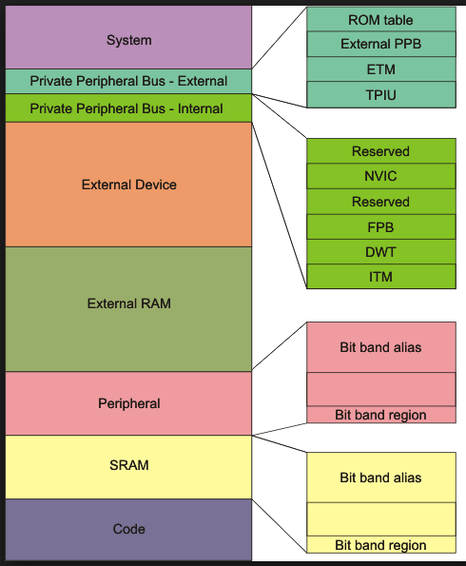

Sources: The arm infocentre.

Expanation: The arm cortex m4 has an address space of upto 4 GB.

Following are the memory regions:

Code region: This is primarily used to store program.

SRAM region: This is primarily used to store data, such as heaps and stacks.

Peripheral region: This is used for peripherals such as Advanced high performance bus or Advanced Peripheral Bus

External RAM Region: This is primarily used to store large data blocks, or memory caches

External Device region: This is primarily used to map to external devices such as SD card.

Internal Private peripheral bus: This is used by processor for internal control. There is special range of memory called System control space of which the Nested Vector Interrupt controller is part of.

BitBand Alias address:

SRAM Region: 32 MB memory space is used as bitband alias region for 1MB data

Peripheral region: 32 MB memory space is used as bitband alias region for 1MB data.

Module 2:

1. Controlling the state of LED using tactile switches.

Two LEDs were controlled using pair of two tactile switches , one to turn the LED On and other one to turn the LED OFF. The operation was done using interrupt handler which was invoked only when the tactile switch was pushed.

1. Try to issue an interrupt on different signal edges (rising edge or falling edge). What changes?

Ans: The only change that happens is that time at which interrupt handler gets invoked. When done on rising edge, the interrupt gets activated when the switch is not pressed.

1. Controlling the volume and pith of sound waves.

The speaker was operated using PWM principle. Since volume of sound waves depends on amplitude and pitch depends on it’s frequency, two potentiometer were used, one to control the volume and other one to control it’s pitch. The values of both potentiometer were being read and then based on its value , a PWM ave was generated which controlled the speaker. The values of potentiometer are also displayed on terminal software like Teraterm.

What changes when you adjust the amount by which variable *i* is incremented/decremented?

Ans: By doing so, we are actually increasing the stepsize by which our triangular wave is increasing. This would in turn increase/decrease the slope and produce change in the sound wave output.

3.

a. Using LCD and shift register

A LCD is being used to display the charaters. The LCD is used in further module to display temperature and count values. Since the LCD is used in 4 bit operation, it would normally require 4 wire for data , however, to reduce the pin count ,SPI protocol is used whose output is given to shift register which then performs serial to parallel data conversion and given to LCD.

b. Using temperature sensor DS1631

A temperature sensor is used to detect the environment temperature

1. Integration

In this, all the above modules are integrated . By this, we are able to display the temperature value directly on LCD rather than displaying it on terminal software.

Module 3:

1. Using RTOS

In this, four threads were executed simultaneously. The first thread being blinking the internal LED, the second thread being controlling the brightness of external LED using the potentiometer, the third thread being displaying the temperature value detected by DS1631 temperature sensor on LCD and the last one being displaying an incremental counter value on LCD. Since , the third and fourth thread were using the LCD , a mutex was being used to protect the access to it and was locked at start of execution of thread and unlocked only when the thread was finished executing.

Module 4:

# List of Project Deliverables.

Doxygen output files and mbed code files for each module is included in the zip file provided with the report.

Module 1:

Real time clock

The snapshot was taken on October 19

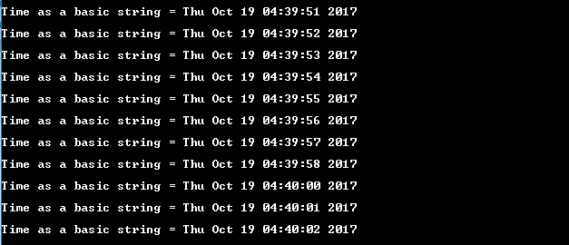

Module 3: Debug Window

Recommendations:

The important parameters in developing Signal analyzer is performance, quality and cost efficiency. Cortex m4 processor does an excellent job to satisfy these parameters. After the evaluation and testing of the board for the given requirements, we can conclude that Cortex m4 is capable to handle the functions required by Keithley’s Signal analyzer. Programming of components, peripheral buses and case of debugging is quite easy on Cortex m4. This makes the project feasible in given time and budget. Hence the recommendation for the use of Cortex m4 in the Signal analyzer product has been given a straight GO.

# References:

1. Project 2 Guide
2. Request for Services
3. Getting Started with ARM using mbed
4. Freescale Kinetis STM32F401 Datasheet
5. Freescale STM32F401 Reference Manual
6. Freescale STM32F401 Platform User’s Guide
7. Module User’s Guides for Modules 1-4.

# Project Staffing:

Vikrant Waje

Graduate Student

University of Colorado Boulder Email: [vikrant.waje@colorado.edu](mailto:vikrant.waje@colorado.edu) Phone: +1 (720)-292-0750